1)Search for EC2 in the Search Bar
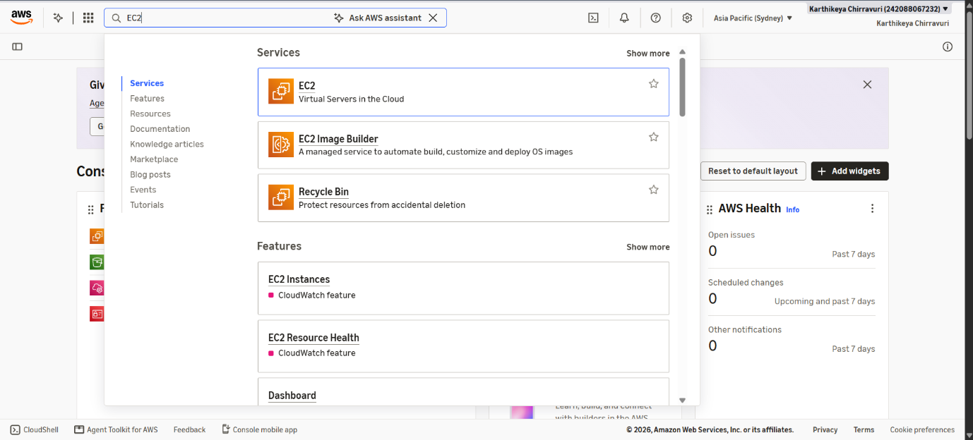

2) Set the Instance name as Nginix Server
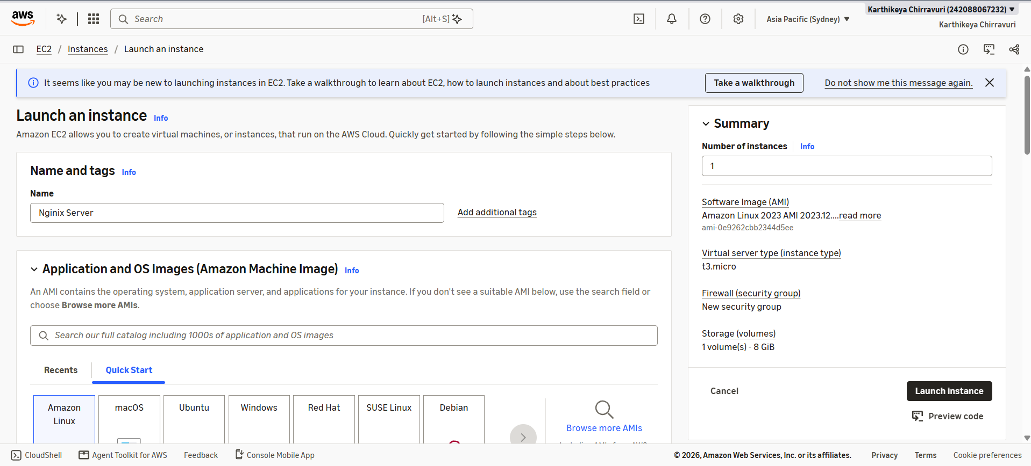

3) Create Key pair named as NginixKey
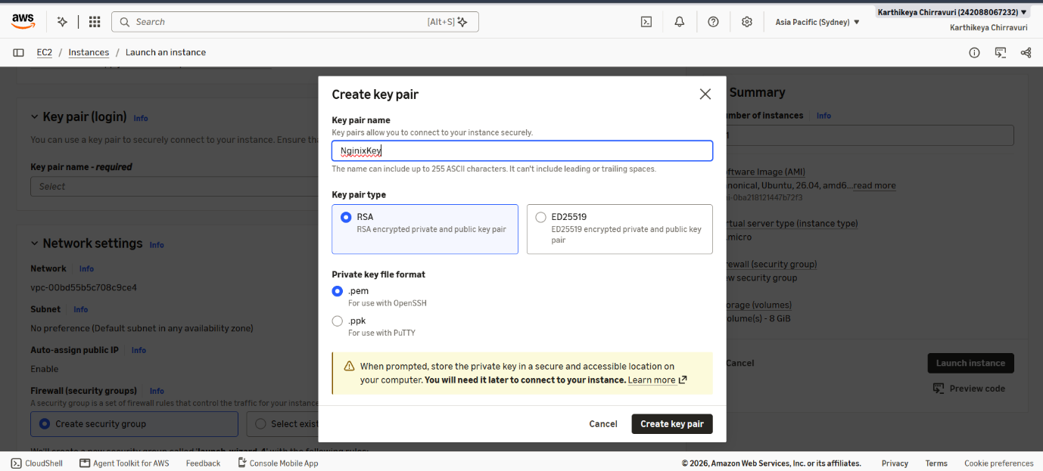

4) Check the Allow HTTP Checkbox
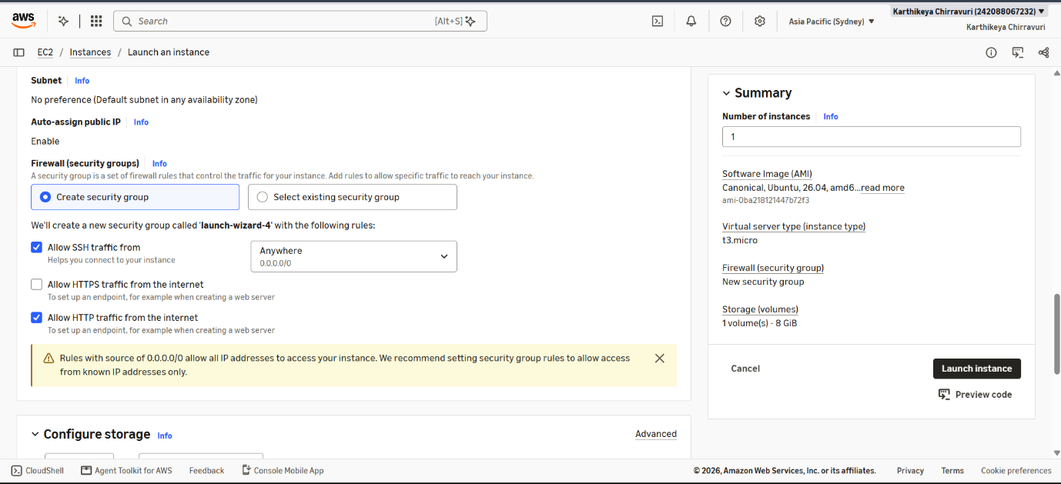

5) Scroll down and paste the following code in the User data Section
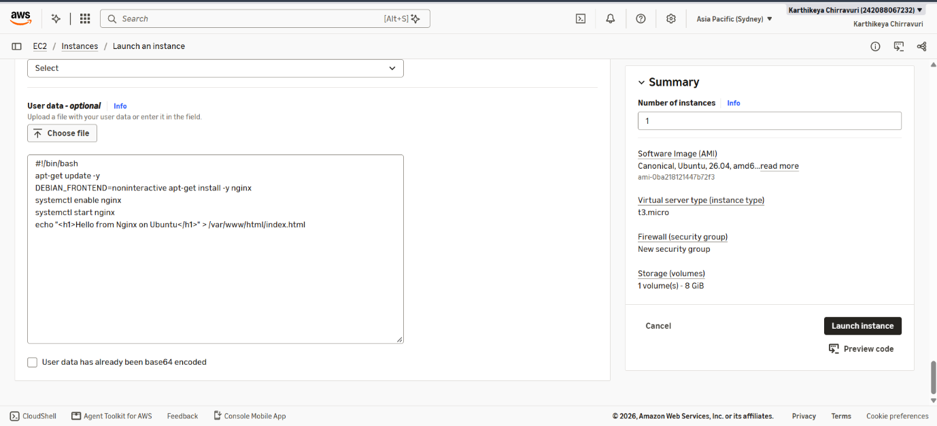

6) Instance is Successfully created
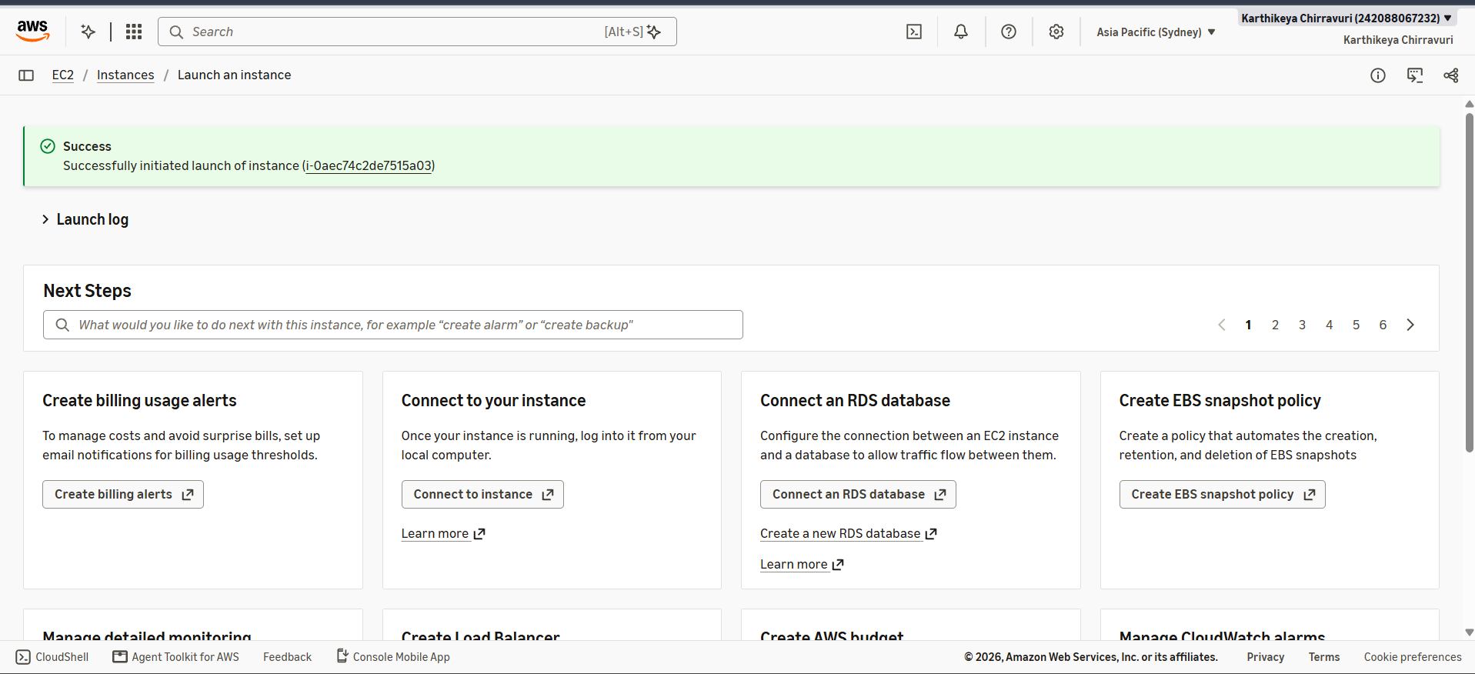

7) Select the instance and click Connect
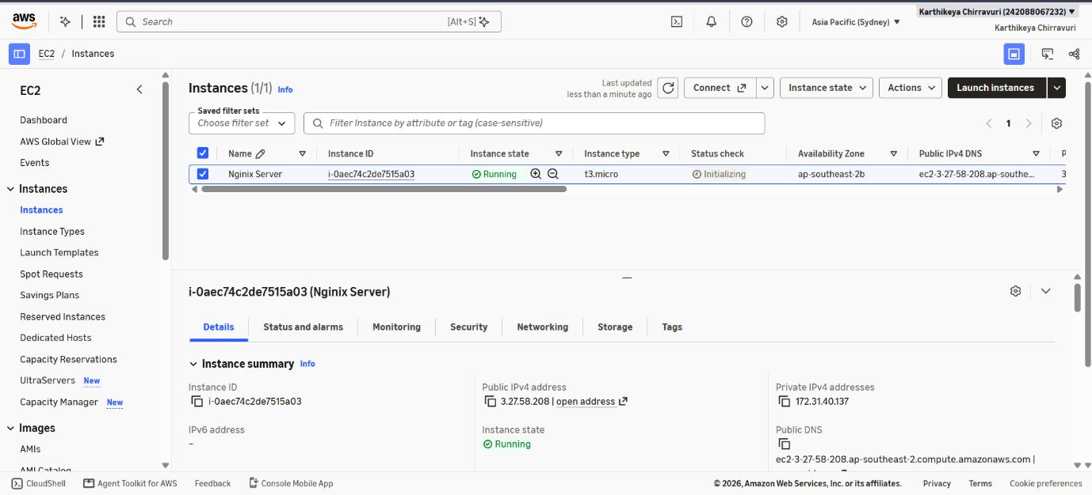

8) Click Connect
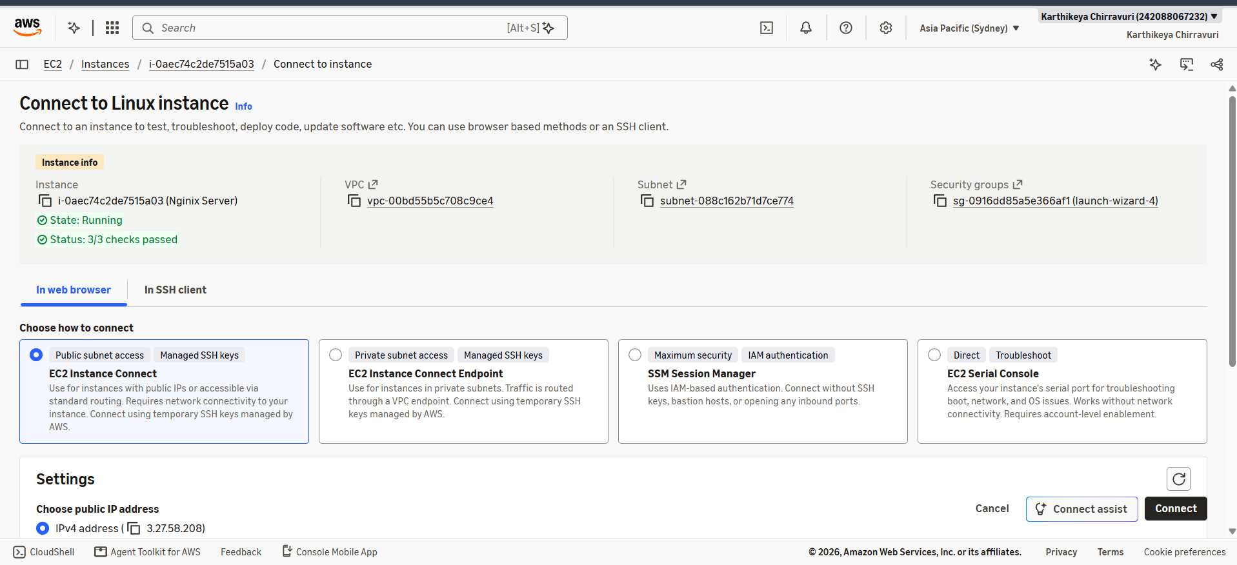

9) Scroll down and Copy the IPv4 Address

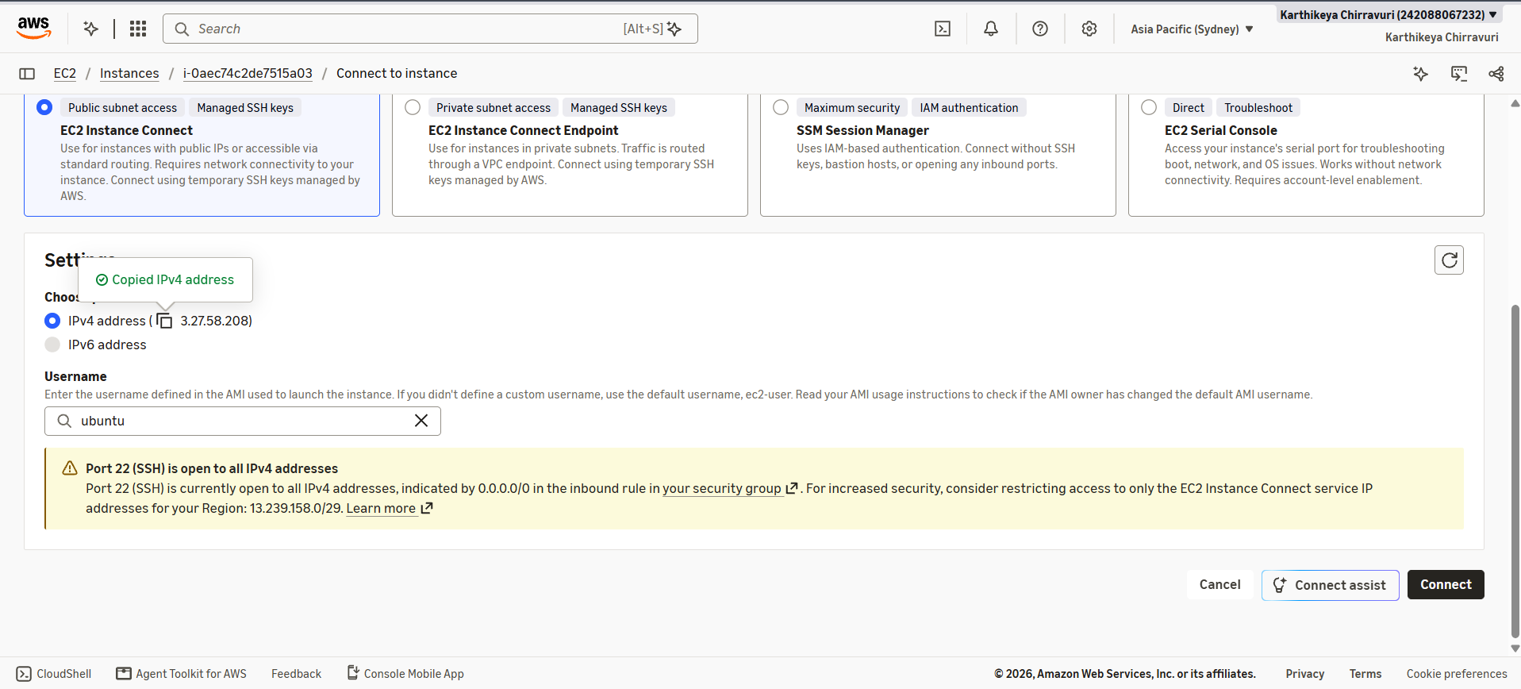

10) Paste the copied link in a new Tab


